**COP 2251C Team Project**

**Project Specifications Document**

**100 points**

**Team Name:**

**(20 pts) Project Description:**

**Interactive loan shopper (ILS) is the ideal tool for the ideal loan. The more lenders you check out when shopping for mortgage rates, the more likely you are to get a lower interest rate. Getting a lower interest rate could save you hundreds of dollars over a year of mortgage payments — and thousands of dollars over the life of the mortgage.**

**With ILS easy-to-use mortgage rate tool, you can compare current home loan interest rates — whether you’re a first-time homebuyer looking at 30-year fixed mortgage rates or a longtime homeowner comparing refinance mortgage rates.**

**ILS loan shopper tool can help you find competitive mortgage rates. Specify whether you’re buying or refinancing. After clicking "Get Started," you’ll be asked the home’s price or value, the size of the down payment or current loan balance, and the range of your credit score. You’ll be on your way to getting a personalized rate quote, without providing personal information. From there, you can start the process to get preapproved for your home loan. It’s that easy.**

**(20 pts) User Stories:**

**As a Business owner, I need to borrow capital so that I can grow my business.**

**As a Potential homeowner, I need to have multiple choices of financing so that I can buy my dream home.**

**As a College Student, I need to find the best possible auto loan rate so that I can buy a reliable car to commute to school.**

**As CFO, I need to find a business loan so that my company can operate for the next fiscal year.**

**As newlywed, I need to find a mortgage that fits my budget so that I can stick to my financial plan.**

**As an Uber driver, I need to find a reliable, gas efficient car so that I can make a living.**

**As an entrepreneur I need initial seed money so that I can launch my venture capital firm.**

**(20 pts) Screen by Screen Design/ Wireframes**

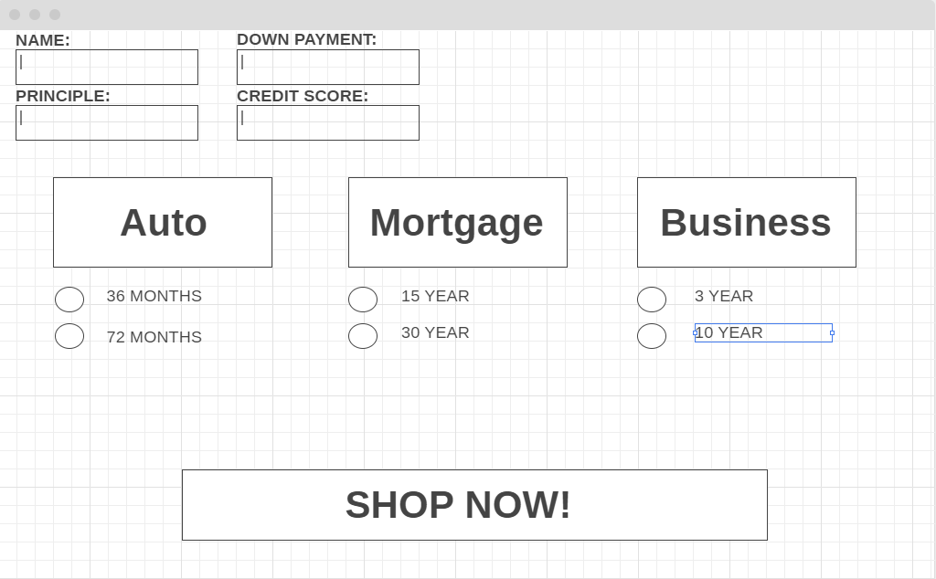

**(20 pts) QA/Testing Conditions/Success Criteria:**

**User Input Validation:**

**-Name**

**-Down Payment**

**-Principle**

**-Credit Score**

**(20 pts) Classes/Databases Needed:**

**-Loan**

**-Auto**

**-Mortgage**

**-Business**

**-Banks**